San Francisco State University School Project

SW Engineering CSC648/848 Spring 2019

SFSURent

Team 11

Cory Lewis(Team Lead, [clewis9@mail.sfsu.edu](mailto:clewis9@mail.sfsu.edu))

Xinyu Zou(GitHub Master)

Soheil Ansari(Back End Lead)

Junwei Liang

Poorva Rathi

David Dropping(Front End Lead)

Chintan Sanjay Puri

Milestone 4

4/30/19

History Table:

1. Product Summary

SFSU Rent

1.1 Unregistered User

* + 1.1.1 Shall be able to browse listings by simply visiting the website.
  + 1.1.2 Shall be able to search the listings by listing types.
  + 1.1.3 Shall be able to view the listings on a map.
  + 1.1.4 Shall be able to filter listings by distance to SFSU, cost, number of bedrooms, and number of bathrooms.
  + 1.1.5 Shall be able to read the description of postings.
  + 1.1.6 Shall be able to view all the listing data to give the user an idea of the living circumstances.
  + 1.1.7 Shall be able to register for an account by completing an online form.

1.2 Registered User (Can perform all tasks of Unregistered User and Landlord)

* + 1.2.1 Shall be able to contact landlord through the platform.
  + 1.2.2 Shall be able to post listings.
  + 1.2.3 Shall be able to use forgot password to recover login.

1.3 Landlord (Can perform all tasks of Registered User)

* + 1.3.1 Shall be able to view postings.
  + 1.3.2 Shall be able to view messages from potential tenants.
  + 1.3.3 Shall be able to delete own postings.

1.4 Administrator

* + 1.4.1 Shall be able to delete any posting.
  + 1.4.2 Shall be able to block accounts.
  + 1.4.3 Shall be able to approve postings of Landlords before they go live.
  + 1.4.4 Shall be able to disapprove postings of Landlords before they go live.

Our product mainly focuses on helping SFSU students to find the perfect living circumstances. We help incoming SFSU students find housing easily by designing our filtering to reference SFSU in terms of travel distance, and price. Landlords looking to rent their property quickly can find a market with our site because each semester SFSU has many incoming students eagerly searching for housing options. Additionally, landlords can list their property with ease due to our Google Maps API integration for address auto fill. Our website makes every effort to be secure and keep our users passwords encrypted so even our administrators cannot view this data.

**SFSU Rent Site:** <http://ec2-18-144-46-90.us-west-1.compute.amazonaws.com/listing/>

1. Usability Test Plan

* Test objectives

The feature being tested in this usability test is the “Search” feature. Search is an integral component of the website as the intended users i.e SFSU students need this feature in order to efficiently find the listing that they are looking for.

* Test description
  + System setup: Single room setup with with observer/monitor close to the evaluator.
  + Starting Point: User clicks supplied URL and is started at the Home Page where available listings can be viewed.
  + Intended users : Since the website is designed to contain housing listings around the SFSU campus, the intended users for this test are **SFSU students with average computing skills**.
  + URL: <http://ec2-18-144-46-90.us-west-1.compute.amazonaws.com/listing/>
  + What is to be measured:  
    For this test, user satisfaction evaluation is the primary metric that is going to be measured.  
    users will be asked to perform the task and then a Likert questionnaire will be used where user answers/rates how they “feel” about usability.
* Usability Task description:   
  Open the website  
  Search for a listing with one room.  
  Search for a listing for females only.  
  Search for all apartments  
  Search for all rooms  
  Search for all bungalows  
  Search for a quiet apartment.

Questionnaire :

|  |  |  |  |  |  |  |
| --- | --- | --- | --- | --- | --- | --- |
|  |  | **Strongly Disagree** | **Disagree** | **Neither agree or disagree** | **Agree** | **Strongly Agree** |
|  | **Questions** | **1** | **2** | **3** | **4** | **5** |
| 1 | I found searching for listings easy to use. |  |  |  |  |  |
| 2 | I found searching for a particular listing (apartment,bungalow,room) simple. |  |  |  |  |  |
| 3 | I found the website easy to navigate. |  |  |  |  |  |

1. QA test plan (2.5 pages MAX)

The Item being tested is the search function. The test objective is to test the accuracy of the %like search. The device the test will be performed on is a Dell XPS laptop. The browsers that we will test our application on are Google Chrome and Mozilla Firefox. The expected time of this test will be less than 10 minutes.

* + **Input**: enter “SFSU”
  + **Output**: Check you get 1 result, containing the string “one” in the name field
  + **Input**: enter filter for $1000-$1500
  + **Output**: Check you get 2 results, both within the price range of $1000-$1500
  + **Input**: enter “student”
  + **Output**: Check you get 7 results, all with the string “title” in the name field

|  |  |  |  |  |  |
| --- | --- | --- | --- | --- | --- |
| Test Number | Title | Description | Input | Expected Output | Result Pass/Fail |
| 1 | Search field test | Test % like in search for name field by entering a single word and comparing the number of responses to the number of expected responses from the database | “SFSU” | Get 5 result, containing the word “sfsu” in the title field | Chrome:  Pass  Firefox:  Pass |
| 2 | Search field test | Test % like in search for name field by entering a single word and comparing the number of responses to the number of expected responses from the database | “1 bedroom apartment” | Get 5 result, containing the word “1 bedroom apartment” in the title field | Chrome:  Pass  Firefox:  Pass |
| 3 | Search field test | Test % like in search for name field by entering a single word and comparing the number of responses to the number of expected responses from the database | “studen” | Get 2 results, all containing the word “student” in the title field | Chrome:  Pass  Firefox:  Pass |

1. Code Review

* Coding Style
  + GitHub Commits: (add|remove|modify|fix) what you did
  + Header Comments:  
    /*  
    Author:  
    Date:  
    Description:  
    */
  + Block Comments: // notes , Name, Date Modified
  + Lint used for code formatting
* Code review is done by the two team members where the emails are exchanged for reviewing the coding style on a block of code (input validation). Below are the screenshots of the emails and the code.
* Email was sent by one member to the team lead to verify the coding style.

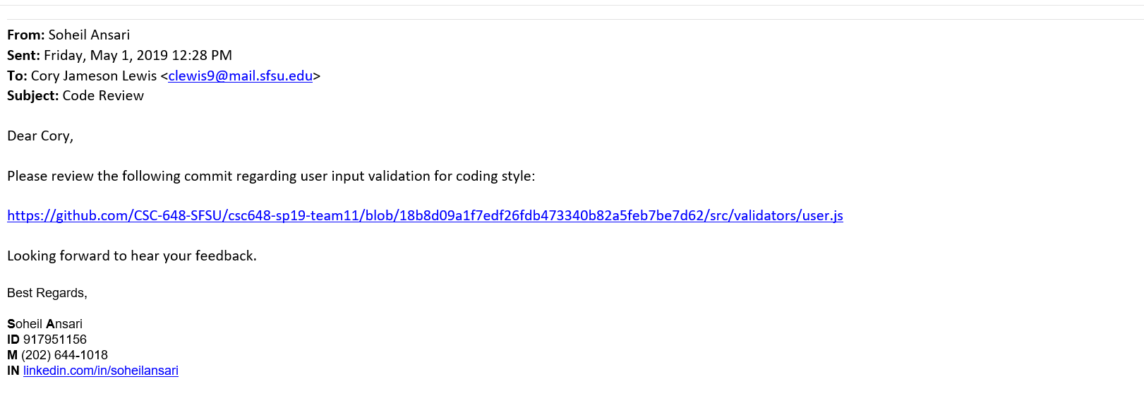

* Code under review:



Email replied by the team lead to encourage the hard work and improve the coding style.

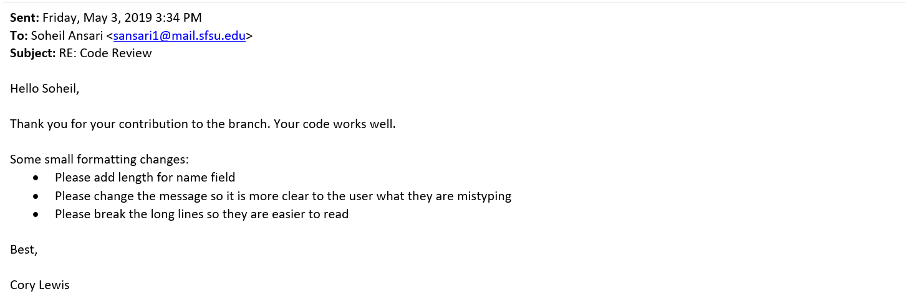

* Code after the review:

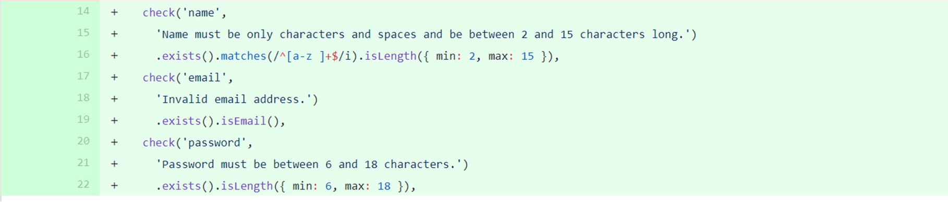

# 

# 5) Self-check on best practices for security

Security and privacy are among the hot topics in the media these days. There have been several scandals this year alone which revealed some major companies were not following basic privacy and security measures which could cause a data breaches and affect the privacy of millions of users. Therefore, we have taken the security and privacy of users into account from the first day of designing our application and implemented measure to cover the most known attacks.

The following lists the major asset that we are protecting in our application:

* User’s login information namely their email and password.
* User’s personal information such as location and phone number.
* User’s listing ownership (not revealing information on landlord on listing page).
* Messages between renters and landlords.

The first measure that we took is to keep the user password encrypted in the database to the website administrators and engineers would not have access to plain text passwords. Moreover, that would avoid the passwords to be revealed in case that the database is compromised. For this purpose we took advantage of bcrypt nodejs package which is the most used library for password encryption. The following figure shows the sample encrypted password saved in our database:

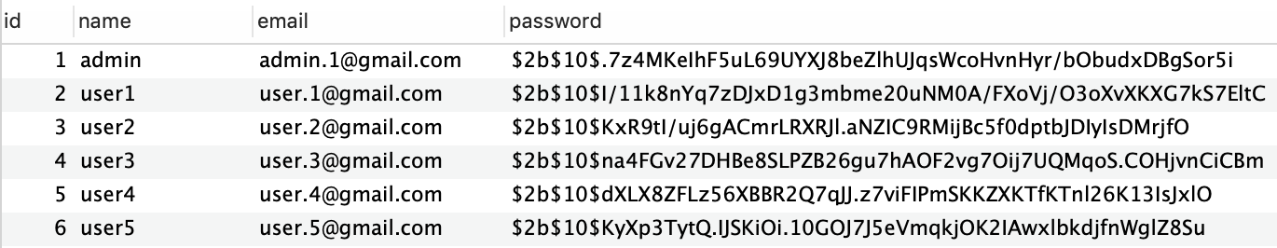

Another important consideration is input validation to prevent a variety of attacks such as SQL injection and Cross-site scripting (XSS). Moreover, it will normalize the content of the website and make it more user-friendly and predictable. To do this, we have taken advantage of the Express Validator library which is the industry standard for input validation in Node JS. More importantly, this library uses Validator.js which provides standard input validation methods. For example, it has methods to detect if an email address is in a valid format. To organize the project we have declared all the validation rules in separate packages in respect to their class. The following code snippet shows our validation rules for creating a new user:

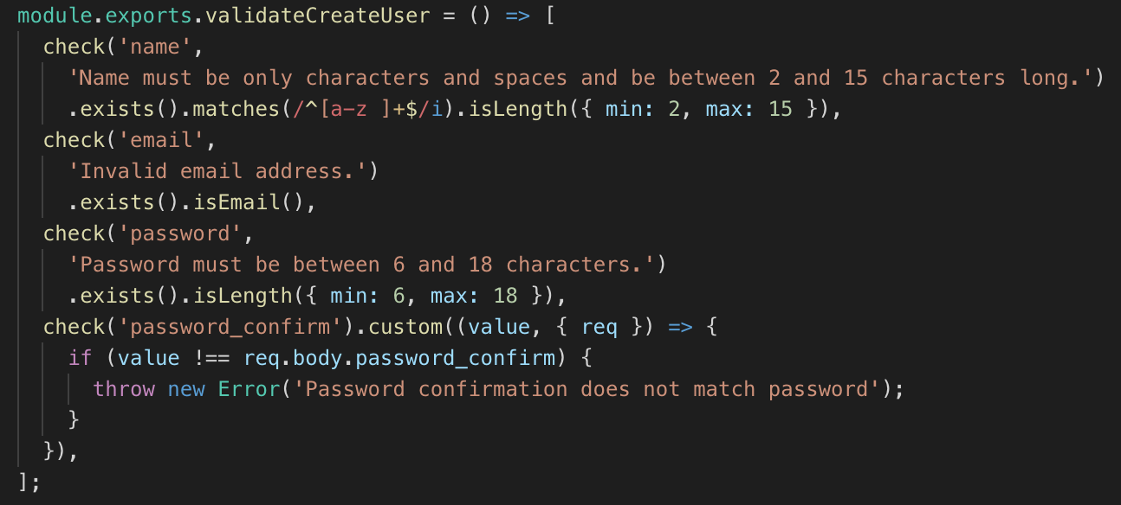

Finally, to protect our web server and database. We have used AWS firewall feature which only allows specific ip address to connect to specific ports. Currently, the only port that is open to public traffic is port 80 which is used for http requests. Our mysql database is listening on port 3306 which is protected by the firewall to only accept connections from within the server.

1. Self-check: Adherence to original Non-functional specs

1.1. Application shall be developed, tested and deployed using tools and servers approved by Class CTO and as agreed in M0 (some may be provided in the class, some may be chosen by the student team, but all tools and servers must be approved by class CTO). - DONE

1.2. Application shall be optimized for standard desktop/laptop browsers e.g. must render correctly on the two latest versions of two major browsers - DONE

1.3. Selected application functions must render well on mobile devices - ON TRACK

1.4. Data shall be stored in the team’s chosen database technology on the team’s deployment server. - DONE

1.5. No more than 50 concurrent users shall be accessing the application at any time - DONE

1.6. Privacy of users shall be protected, and all privacy policies will be appropriately communicated to the users. - DONE

1.7. The language used shall be English. - DONE

1.8. Application shall be very easy to use and intuitive. - ON TRACK

1.9. Google analytics shall be added - DONE

1.10. No email clients shall be allowed - DONE

1.11. Pay functionality, if any (e.g. paying for goods and services) shall not be implemented nor simulated. - DONE

1.12. Site security: basic best practices shall be applied (as covered in the class) - DONE

1.13. Before posted live, all content (e.g. apartment listings and images) must be approved by site administrator - Done

1.14. Modern SE processes and practices shall be used as specified in the class, including collaborative and continuous SW development - DONE

1.15. The website shall prominently display the following exact text on all pages *"SFSU Software Engineering Project CSC 648-848, Spring 2019. For Demonstration Only”* at the top of the WWW page. (Important to not confuse this with a real application). - DONE